Router Sled User Manual

# Router Sled Parts

## Overview

Hoist Gantry –Used to flip large slabs with the help of snatch rings, winches, and rope

Router Gantry – Holds the router

Riser Rails – added to provide more clearance when surfacing extra tall work pieces. The riser rails and the posts have coinciding numbers for ease of install. You will need to level these to ensure they are as flat as possible.

Foundation – holds everything together. The foot of post #2 (the one closest to the door) has shims underneath it. While there are leveling feet in each post, I found shims easier. I have also marked the floor with gold spray paint for reference since concrete is not always perfectly flat. I did add reinforcement strips near the floor between each post. They make sweeping a pain but reinforce the foot location to help prevent racking. Racking could cause coplanar issues when flattening big pieces.

Rails – DO NOT DAMAGE THESE!

* While the rails are part of the foundation, they are the most important part on this entire structure. The Router Gantry uses these for reference. Every effort has been made to ensure these are perfectly flat, level, and coplanar. The pine rails tend to splinter the tops and inner sides with repeated use. This is not surprising since this is where the bearings on the router gantry contact the rails. To prevent this, I coated these sections of the rails with epoxy and sanded them flat to enhance their durability.
*  When lowering your router height, do so with the router near the edge of the rails closes to you, as this will minimizing creating sagging in the gantry rails.
*  When you intend to mill wide slabs, or you need the best results possible, it is a good idea to check the levelness of the gantry rails periodically to ensure they have not started to sag from mishandling. Use a 4’ Level from Harbor Freight to check. If the gantry rails are not level, place (2) stacked 2x4s or a 4x4 in the middle of the foundation and add a clamp to each side of ONE gantry rail and straighten each rail separately. Only aim to create ~1/2” bend in the rail at a time to slowly reshape it.

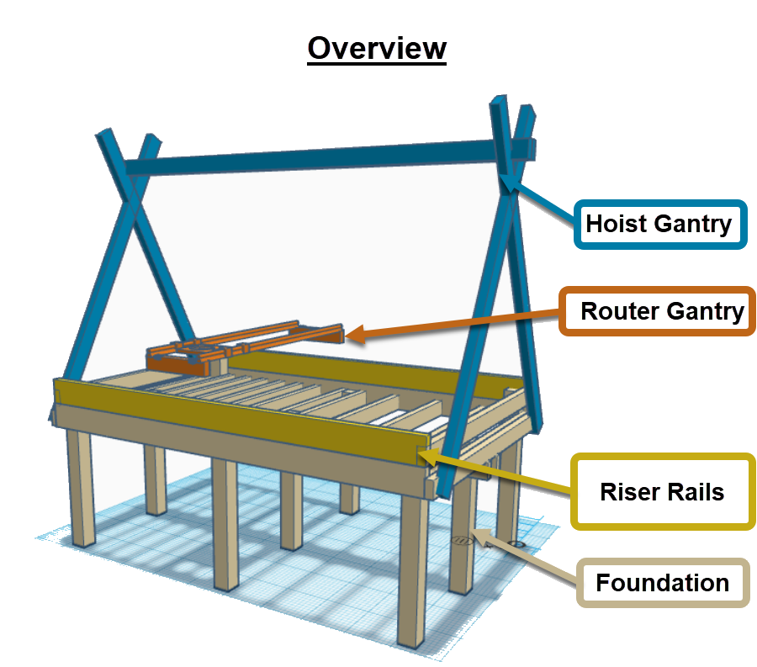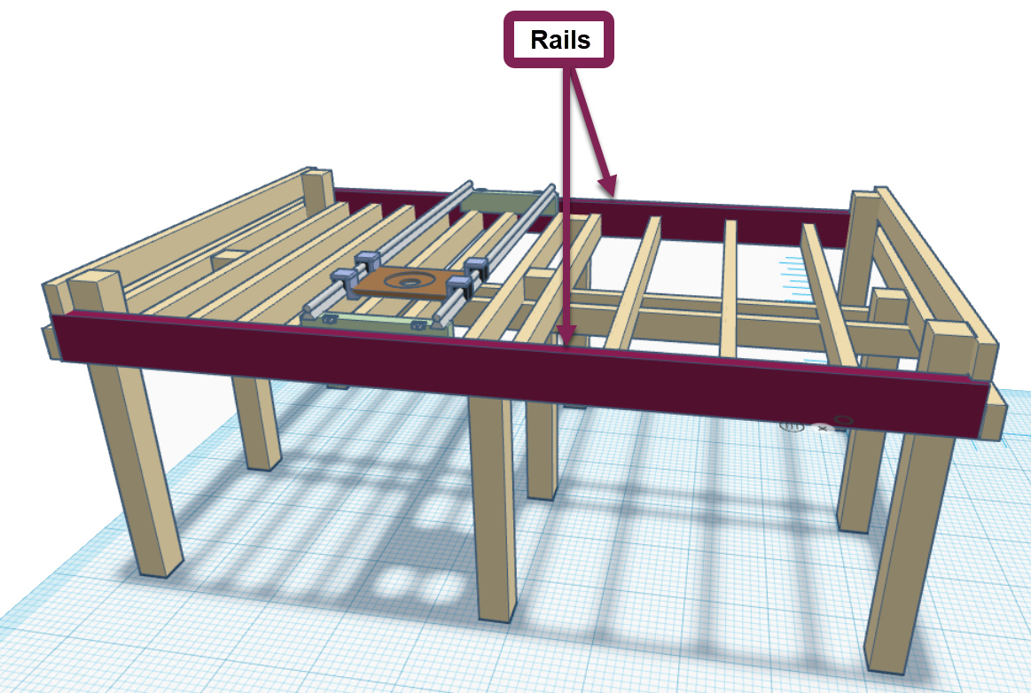

## Router Gantry

Bearing Assembly (4) – guides router gantry along rails

Gantry Tensioner (3) – (not pictured) but mounted between the bearing assemblies on either end of the router gantry to help keep the gantry from racking.

Bearing Housing Offset (2 Left, 2 Right) – serves as a mount between the linear bearings and the router base. Decreases clearance of the router to the workpiece.

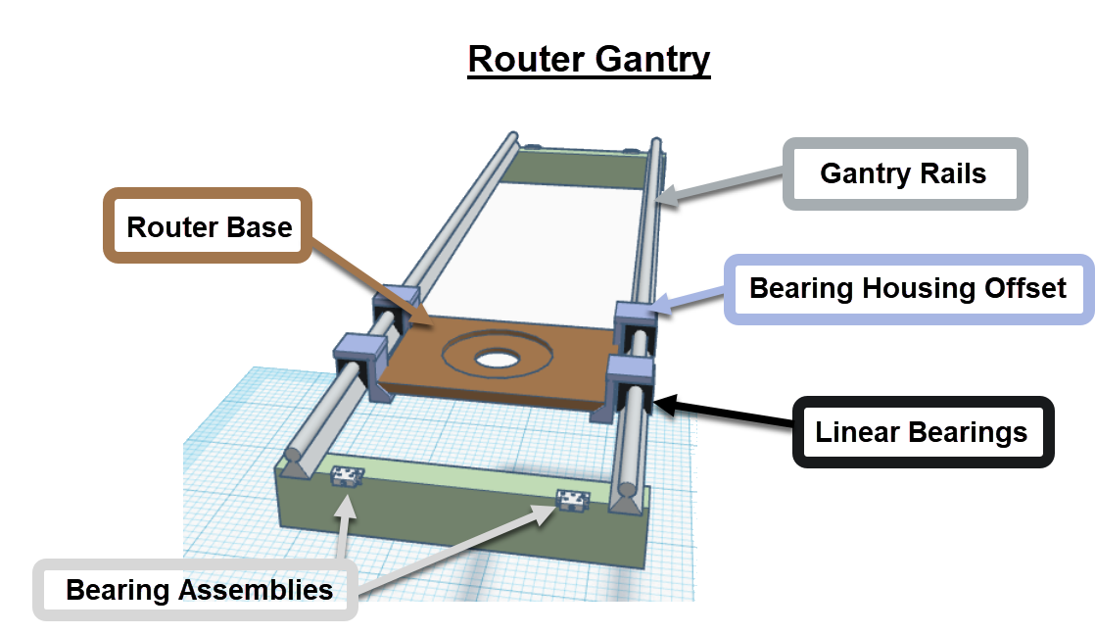

## Bearing Assembly (4)

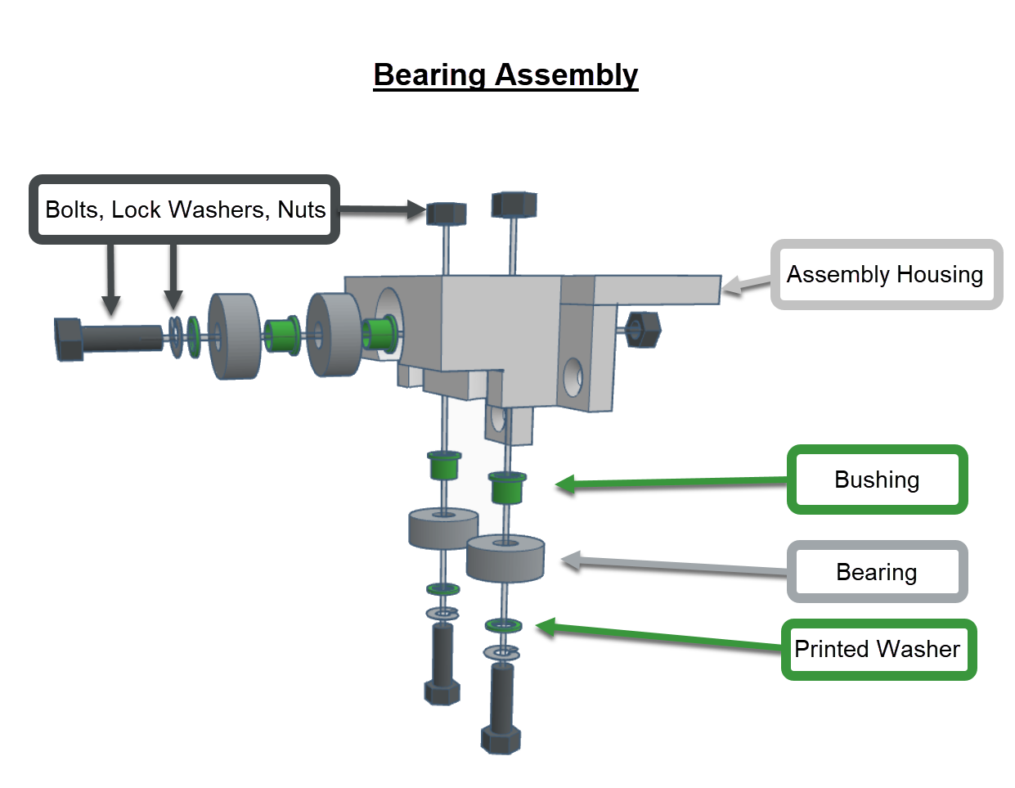

## Accessories

Plunge Router Depth Stop increment gauges

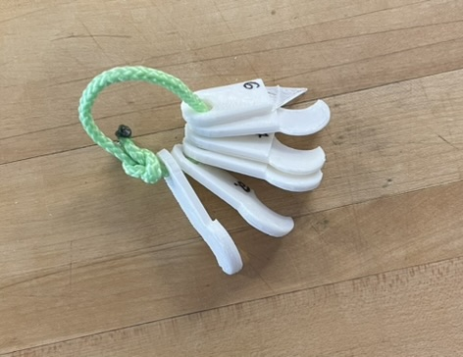

Dust Separator with pressure relief valve. I’m using a [5 hp ridgid shop vac](https://www.homedepot.com/p/RIDGID-12-Gallon-5-0-Peak-HP-NXT-Wet-Dry-Shop-Vacuum-with-Filter-Locking-Hose-and-Accessories-HD1200/304006023). Without the relief valve, the trash can collapses, and the suction becomes worthless.

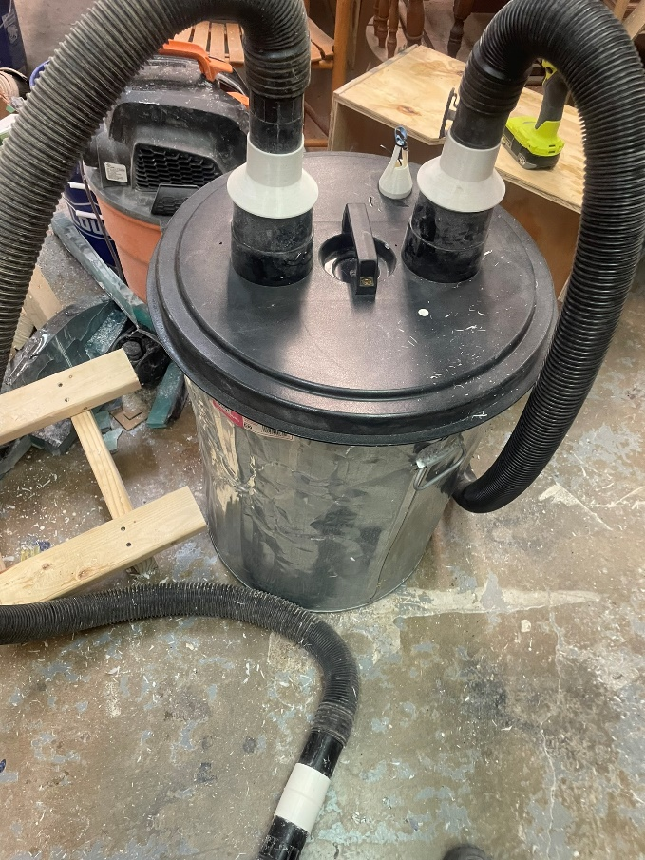 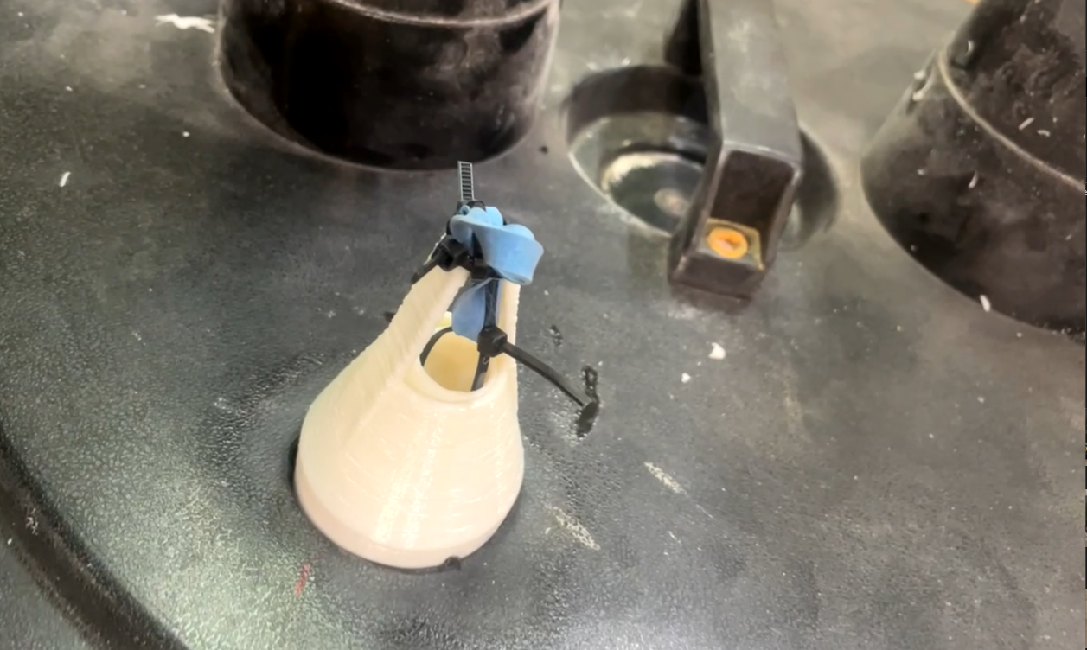

# Part Replacement

## 3D Prints

All parts were printed with Hatchbox’s 1.75 PETG filament with 5 shells and 35% infill for maximum rigidity and durability. The settings captured below are mostly for my reference.

I printed on a FlashForge Creator Pro using the following settings. I preheated the build plate and kept the chamber closed to maintain a steady temperature. If you do not do this, the bearing assemblies will warp.

FlashPrint Settings for bearing assemblies

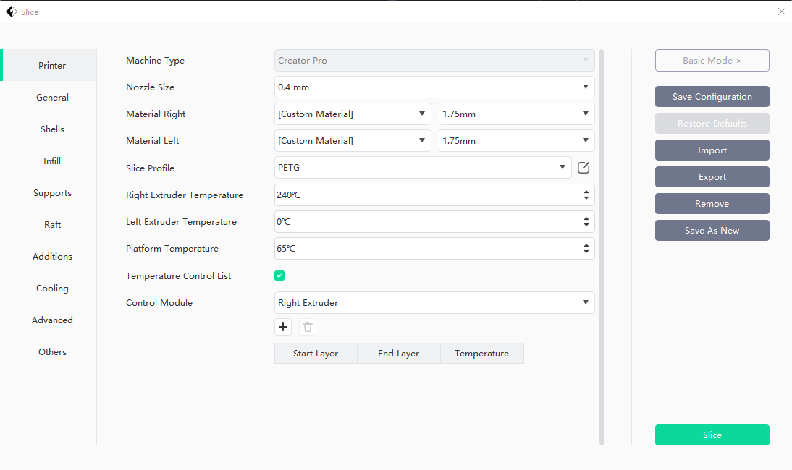

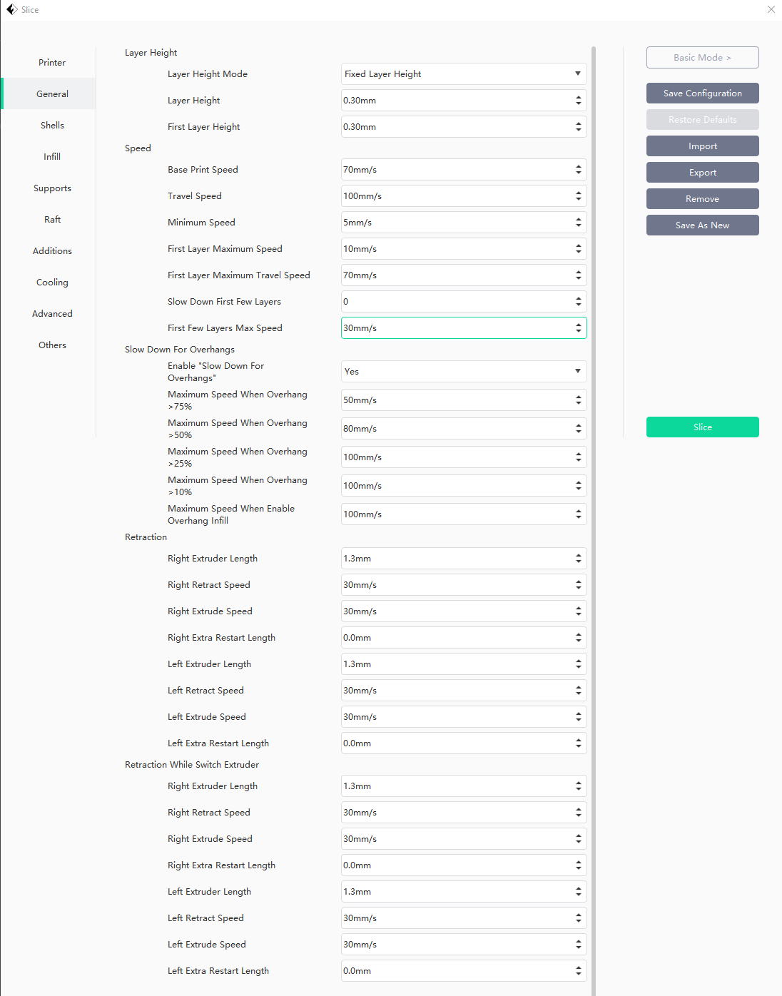

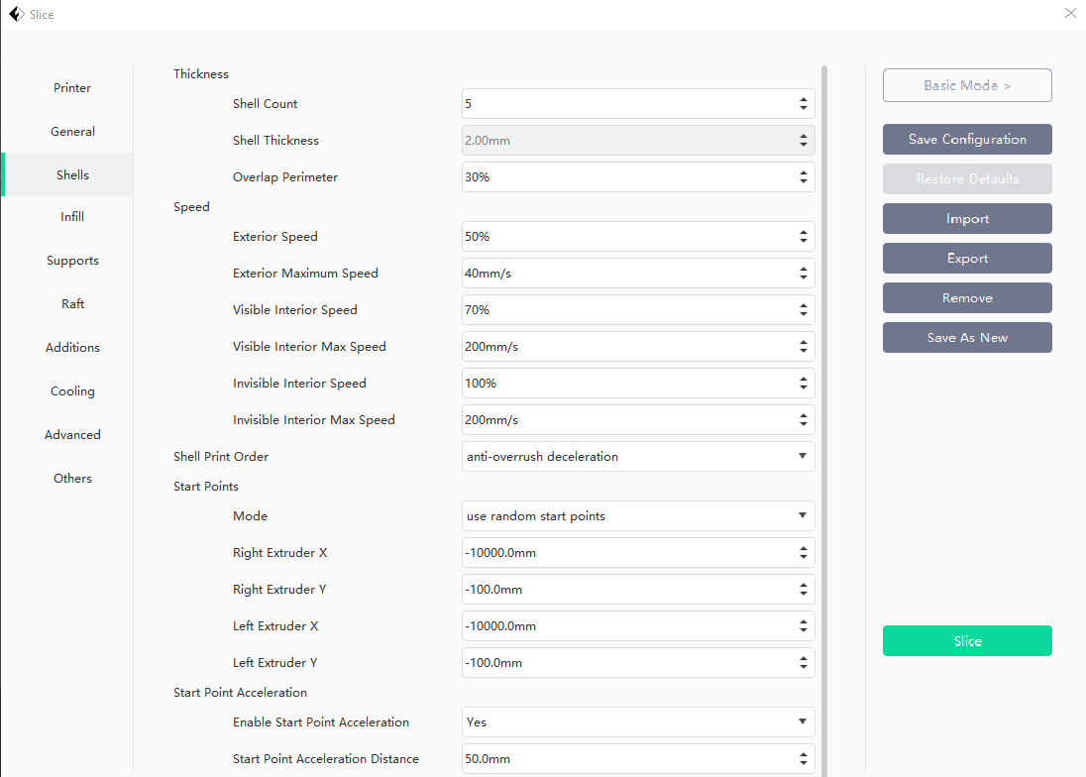

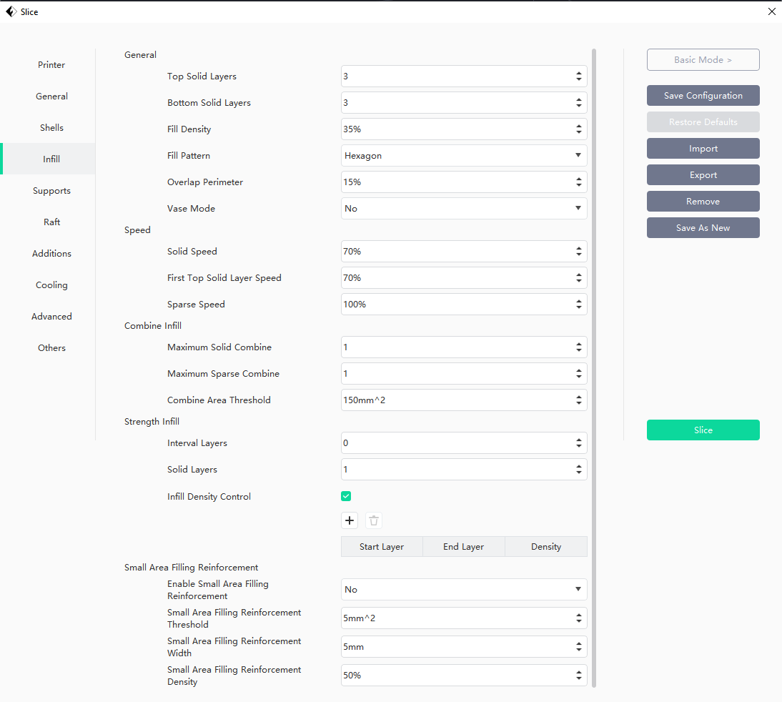

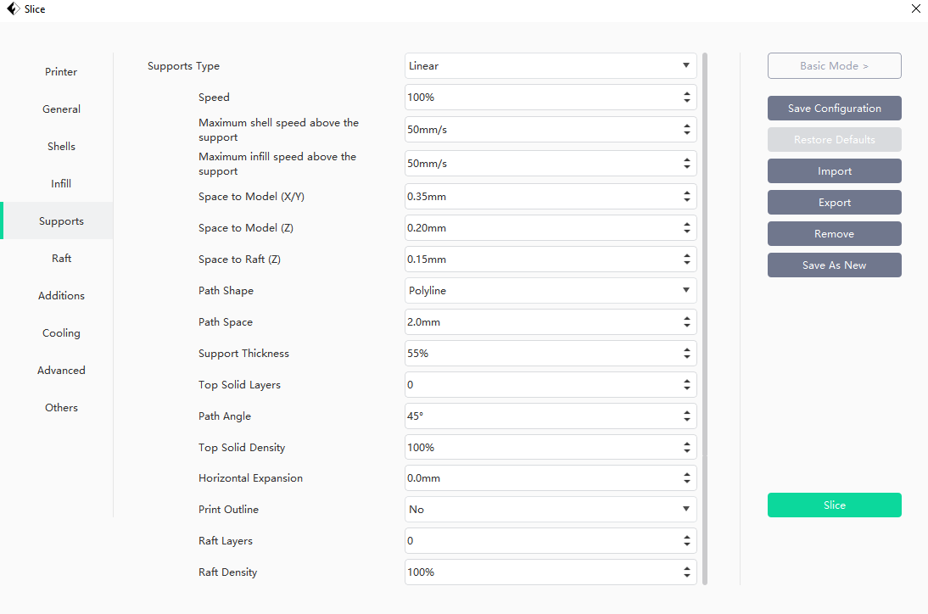

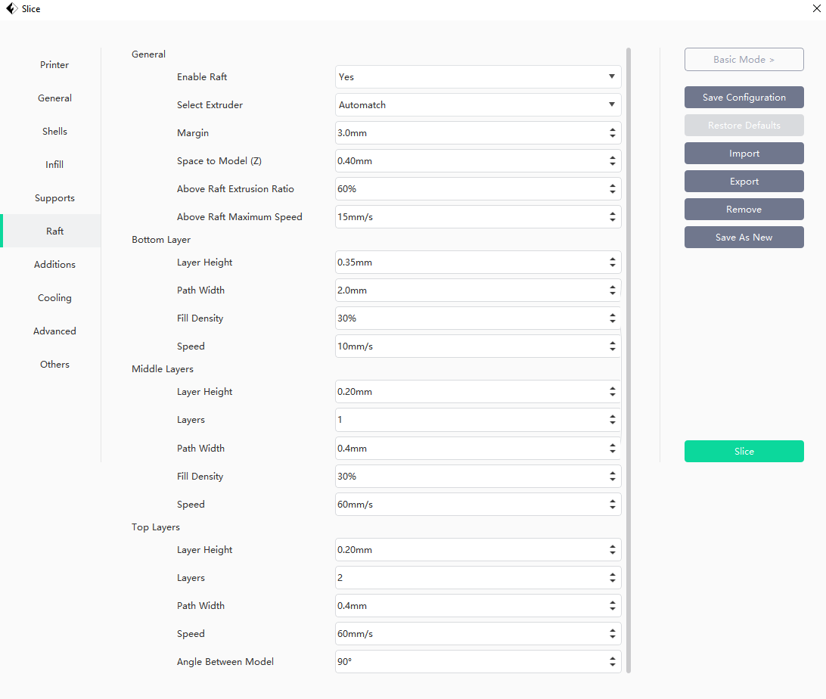

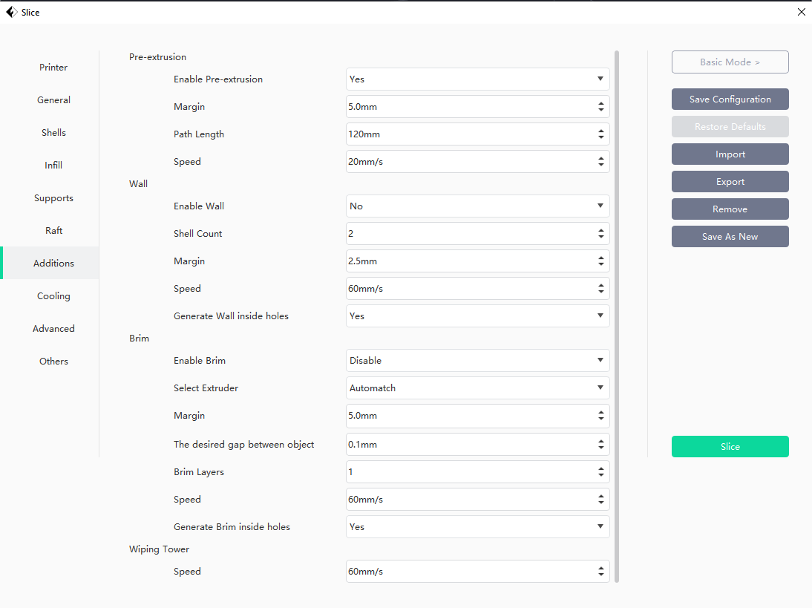

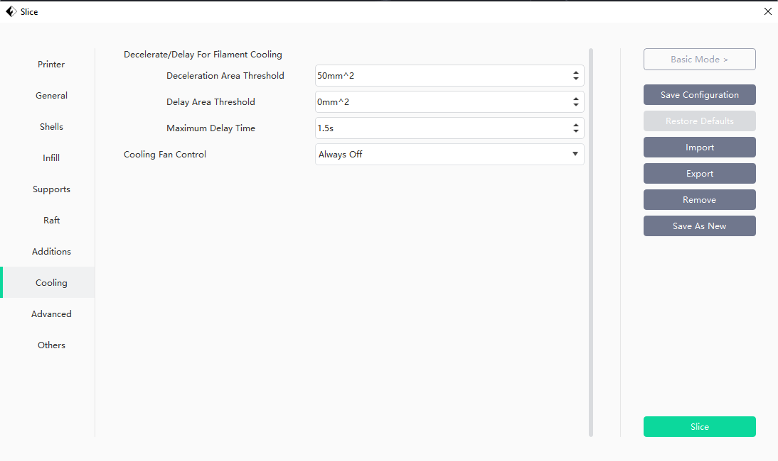

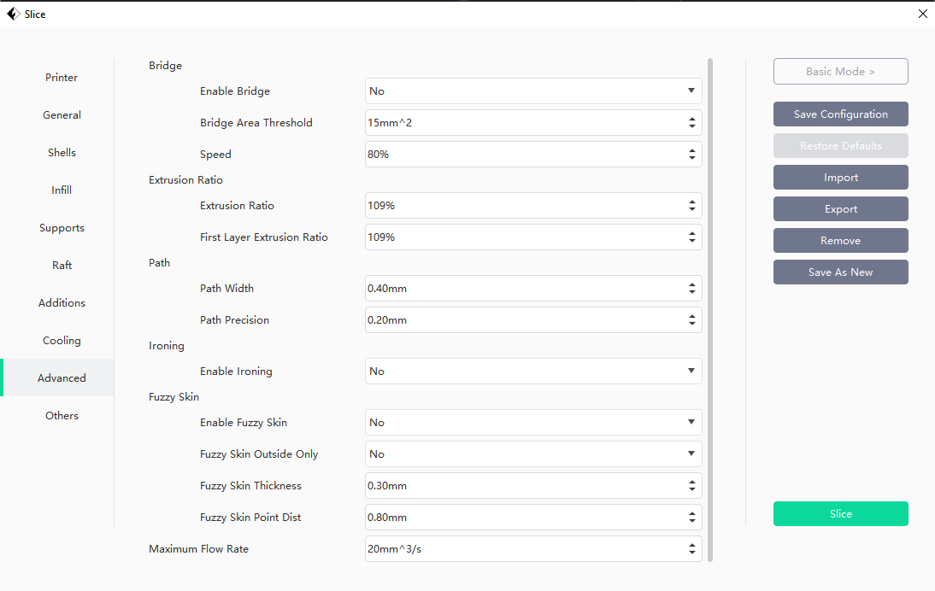

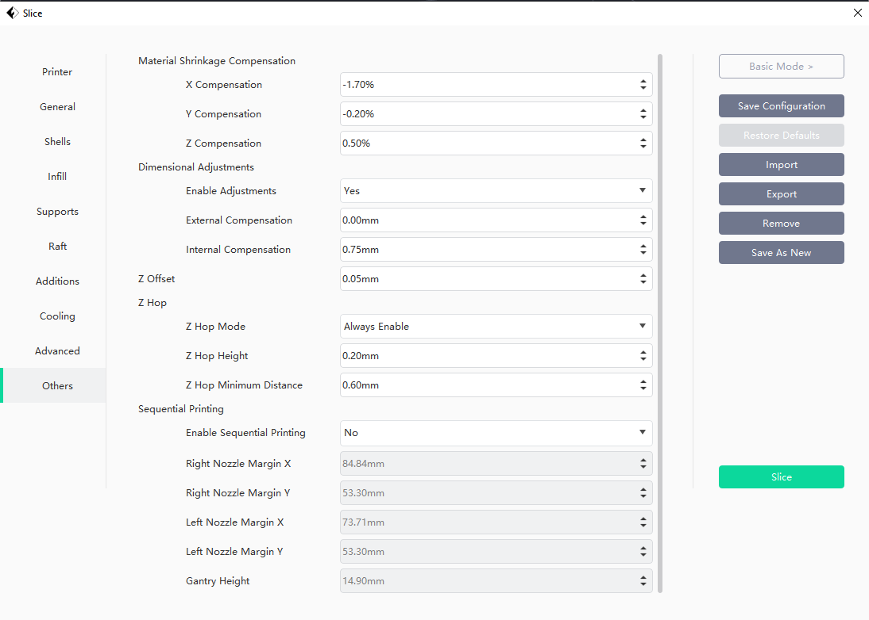

Cura print settings for bushings and washers: infill didn’t matter, no support, no raft,

Flashprint is great for supports. However, I had problems with it printing the bushings and washers; they didn’t want to adhere to the bed. So, I used Cura to print those. Therefore, you will need to calibrate the holes for the bushings and housings AND for the bearing assemblies (they are different).

Test Print Calibration – Use these 2 files to dial in the calibration of holes before printing the assemblies.

All Prints Used for this build:

* 4 Bearing Assemblies
* (16) bushings (4 per assembly, printed in Cura)
* (12) printed washers (3 per assembly, printed in Cura)
* (2) Left Bearing Housing Offsets
* (2) Right Bearing Housing Offsets
* 2.5” Vacuum Hose Coupler
* (2) 4” to 2.5” Hose Adapter
* Pressure relief valve (eloquently calibrated via zip ties and broccoli rubber band)

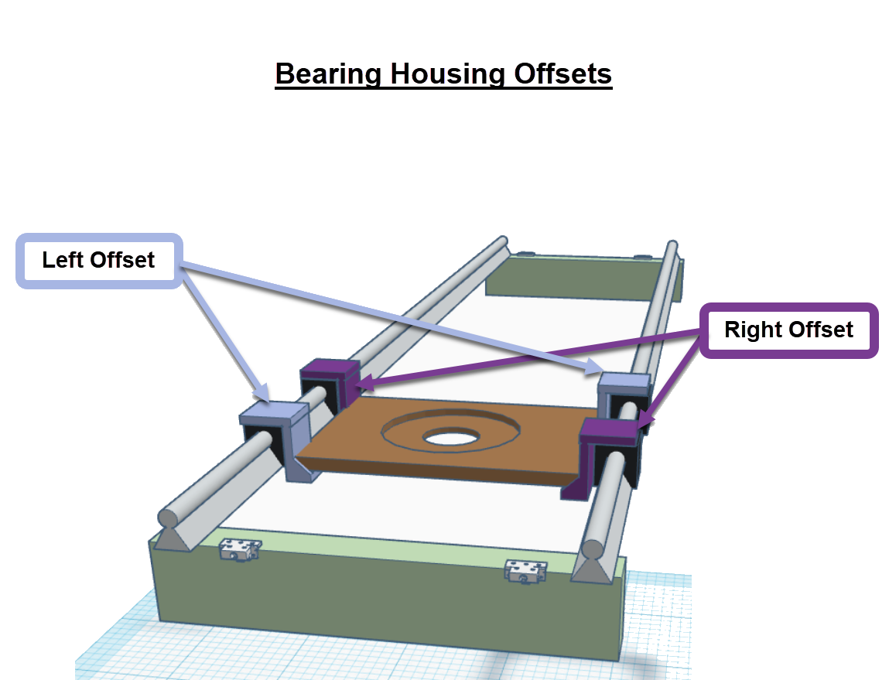

## Purchased Hardware

### Foundation, Rails, Riser Rails, and Hoist Gantry

* Lumber
  + 2 x 4 x 8
  + 2 x 4 x 10
  + 2 x 6 x 10
  + 4 x 4
* ½” Nuts
* ½” Bolts
  + 6”
  + 8”
* Cable Puller (2)
* Snatch Ring (2)
* Rope



### Router Gantry

Router Base bolts

Bearing Housing Offset bolts

Rails

Linear Bearings



### Bearing Assemblies

Horizontal bolts are ¼” x 1.5”

Vertical bolts are ¼” x 2”

Split Lock Washers ¼”



# Flattening

## Materials

* Router
* Bit
* Bit extension (2)

## Directions

Towards you and to the left in ~1” passes has worked the best for me. Some prefer to run it with the grain. If milling epoxy, here are a few tips that help:

1. Warm the epoxy before the pass with a heat gun
2. Turning off the AC in the room for a few days
3. Use fresh blades on your router bit
4. Taking really small passes with the router (like ¾” max and slow)
5. Chipout can be repaired with CA glue.
6. If you create a crack in the epoxy, sand it down with angle grinder or aggressive sander, and pour a patch of color-matched epoxy

## Oversize Pieces

For workpieces that are greater than the two furthest cross members, you may slide the piece down to flatten one end, then slide it the other way to flatten the other. Doing so, will not be perfect, but is a serviceable solution provided the workpiece is not too tall to slide below the frame.

## Reflatten the Foundation

If you need it perfectly flat, use a second bit extension to flatten the foundation. I have spary painted spots on the floor for where I leveled the foundation to. The leg closes to the door (leg 2, as denoted on the top of the post) has a shim under it.

# Rig, Hoist, Flip

## Overview

***WARNING: This Router Sled and all accessories belong to the River Park Wood and Art Club. This is not a professional setup. By using this, you accept the risk and liability. Before using this, you must be a member of the River Park Wood and Art Club, and therefore have signed the liability release waiver.***

***WARNING: Never lift overhead and never get under a workpiece. Always add backup safety straps whenever lifting in case of main rope failure.***

This guide is meant to serve as a starting basis on how to rig, hoist, and flip a workpiece with limited risk.

* Working Load Limit (WLL) is a fraction of the Breaking Strength (BS). For this system, due to the limited hoist length, and non-overhead use.
* For ratings in kN, 1 kN is ~220 lbs, so a 23 kN limit = 5060 lbs.

## Rope

The weakest point in a rope is the knot. Most knots diminish the WLL by 25-50%; some up to 75%. So, a working load of 1000 lbs. could become as little as 250 lbs.

The [orange rope in the Old Art Room](https://www.amazon.com/gp/product/B093PQQ375/ref=ppx_yo_dt_b_search_asin_title?ie=UTF8&psc=1):

* ***WLL of 528 lbs*.** BS of 3520 lbs. With a figure 8 knot, the BS is 2,650 lbs and has a WLL of 528 lbs when using a safety factor of 5.
* ***Rope due for disposal on June 28, 2034***. (10 years from date of purchase)

## Rig

When rigging a slab or completed piece to hoist, the angle of the sling around your workpiece further increases the tension on the rope.

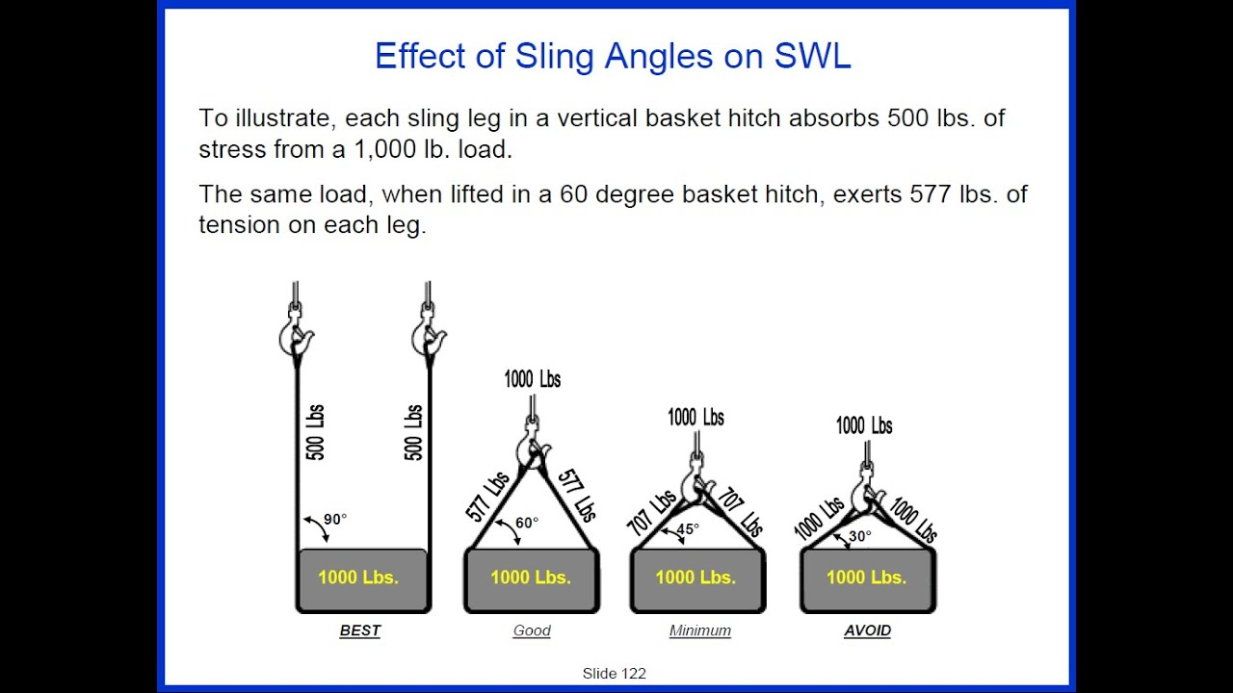

As demonstrated in the image above, as the sling length decreases, the angle of the sling legs decreases, which multiplies the load added to the rope.

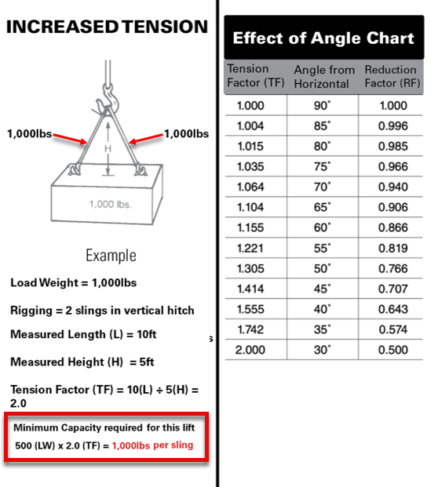

For 60-degree sling angles, the WLL of the supplied rope decreases from 528 lbs down to 457 lbs.

For quick reference, the table below is 7’1” x 46” x 1/75” and weighs roughly 300 lbs. Each walnut slab is 70-80 lbs, and the uncured epoxy weight is 126 lbs (14 gallons).

## Hoist

Avoid jerking the load as you hoist it up or down. Jerky maneuvering can easily double the load weight.

## Flip

https://www.youtube.com/watch?v=W16BWTuQFtc

# Table Legs

There is not good guidance on the width of table legs. However, if you are doing a river table, you don’t want to drill into epoxy; the hardware will show through, and it can also crack.

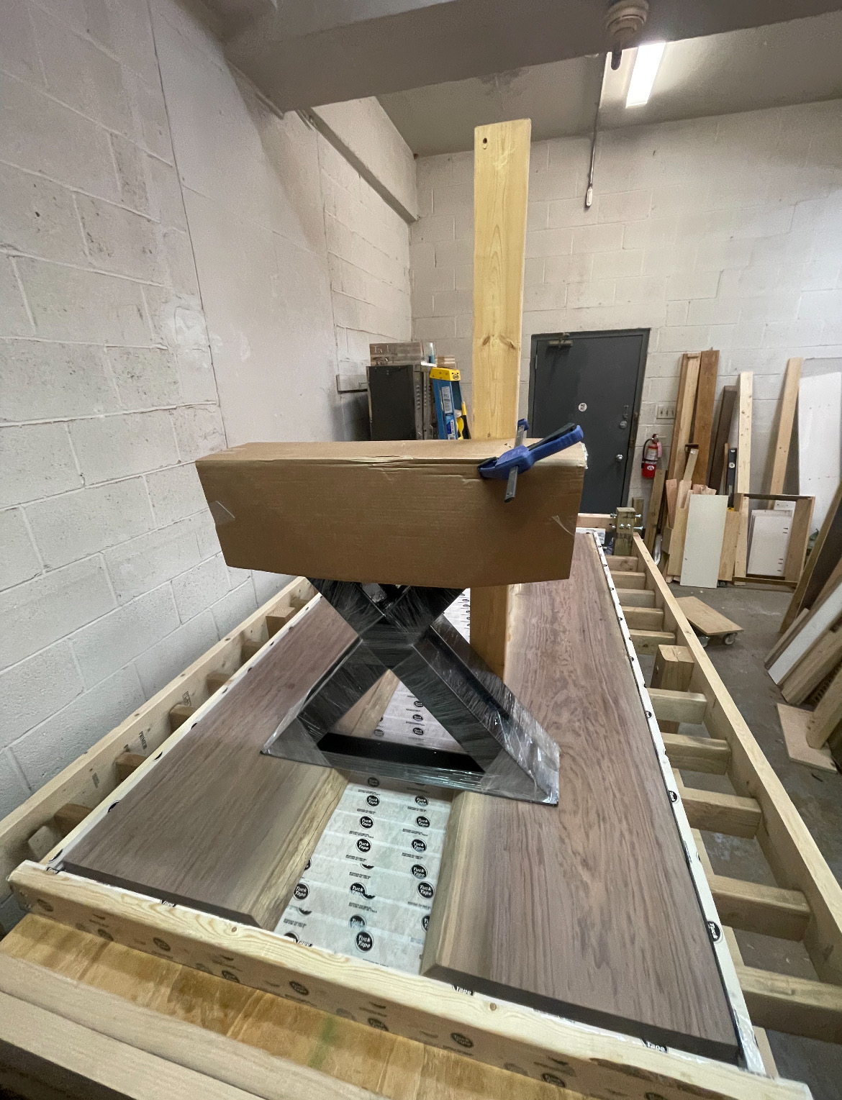

For this table, I could only use a tiny portion of the bolt holes, which wasn’t ideal for a table of 300 lbs.

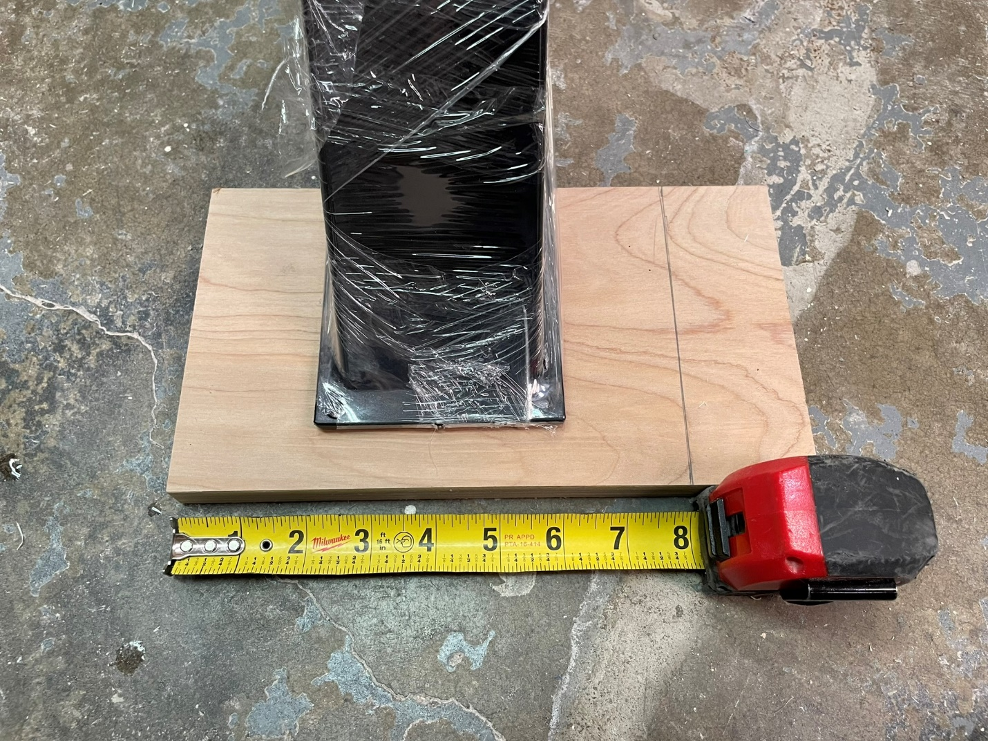

So, I had 6”x 6” plates welded to each side, cut off the crossmember, drilled holes, and painted. Avoid the added cost and work. For a table like this, the holes should be at least 4” apart. If you are doing etsy, spend an extra $50-100 to have extra plate welded if you think it suits your use case. For reference, these table legs were $400 before the extra $200 to have the plates welded. Seems like a lot, but that’s comparatively cheap; table legs are expensive.

Fwiw, Hammered black satin by Rust-oleum is a decent match, but certainly not perfect.

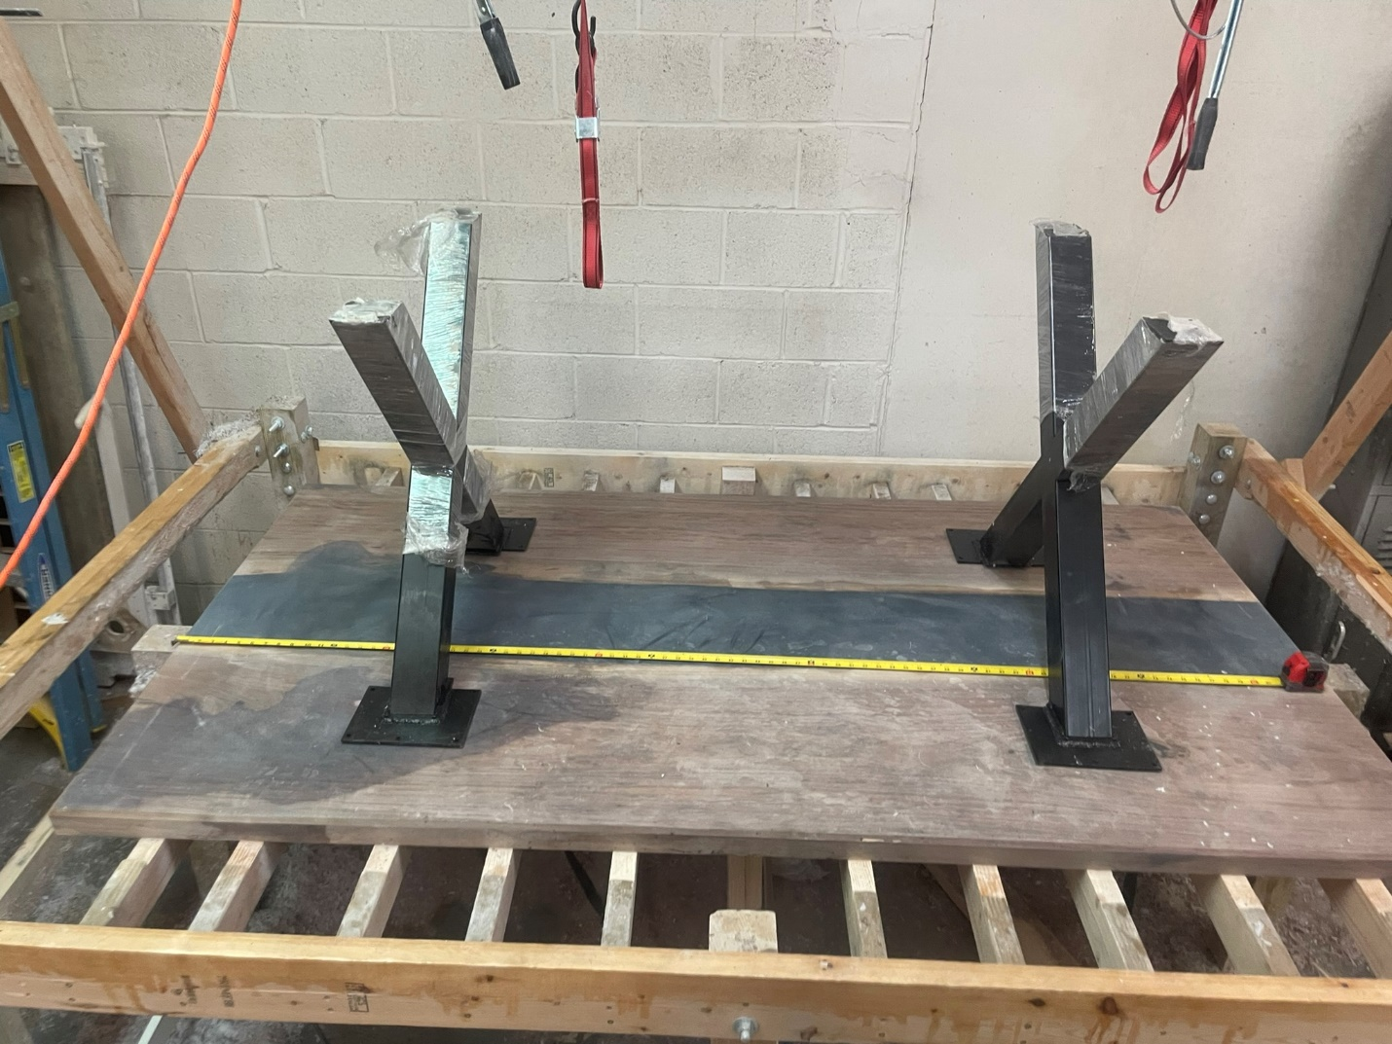

# Epoxy Table

Making an epoxy table requires a lot of tools and materials. I’ve created a list with notes here: <https://www.amazon.com/hz/wishlist/ls/2T5CPWIJCLLNZ/ref=nav_wishlist_lists_2>

I used [Blacktail studio’s Epoxy table workshop course](https://www.blacktailstudio.com/resin-workshops-1). The following sections identify things I’ve learned that work well for me.

## Calculating Epoxy

The bottom of your pour will not be a solid layer of epoxy, even if your slabs are perfectly flat. The bottom will most likely need to be flattened when you finish because not only will you get weird pockets of epoxy and non-epoxy, every tuck tape seam will show.

Calculating the bottom layer is difficult, and you never get an even layer. Here is some overage since I only wanted a 1/4” in order to have a dark bottom layer.

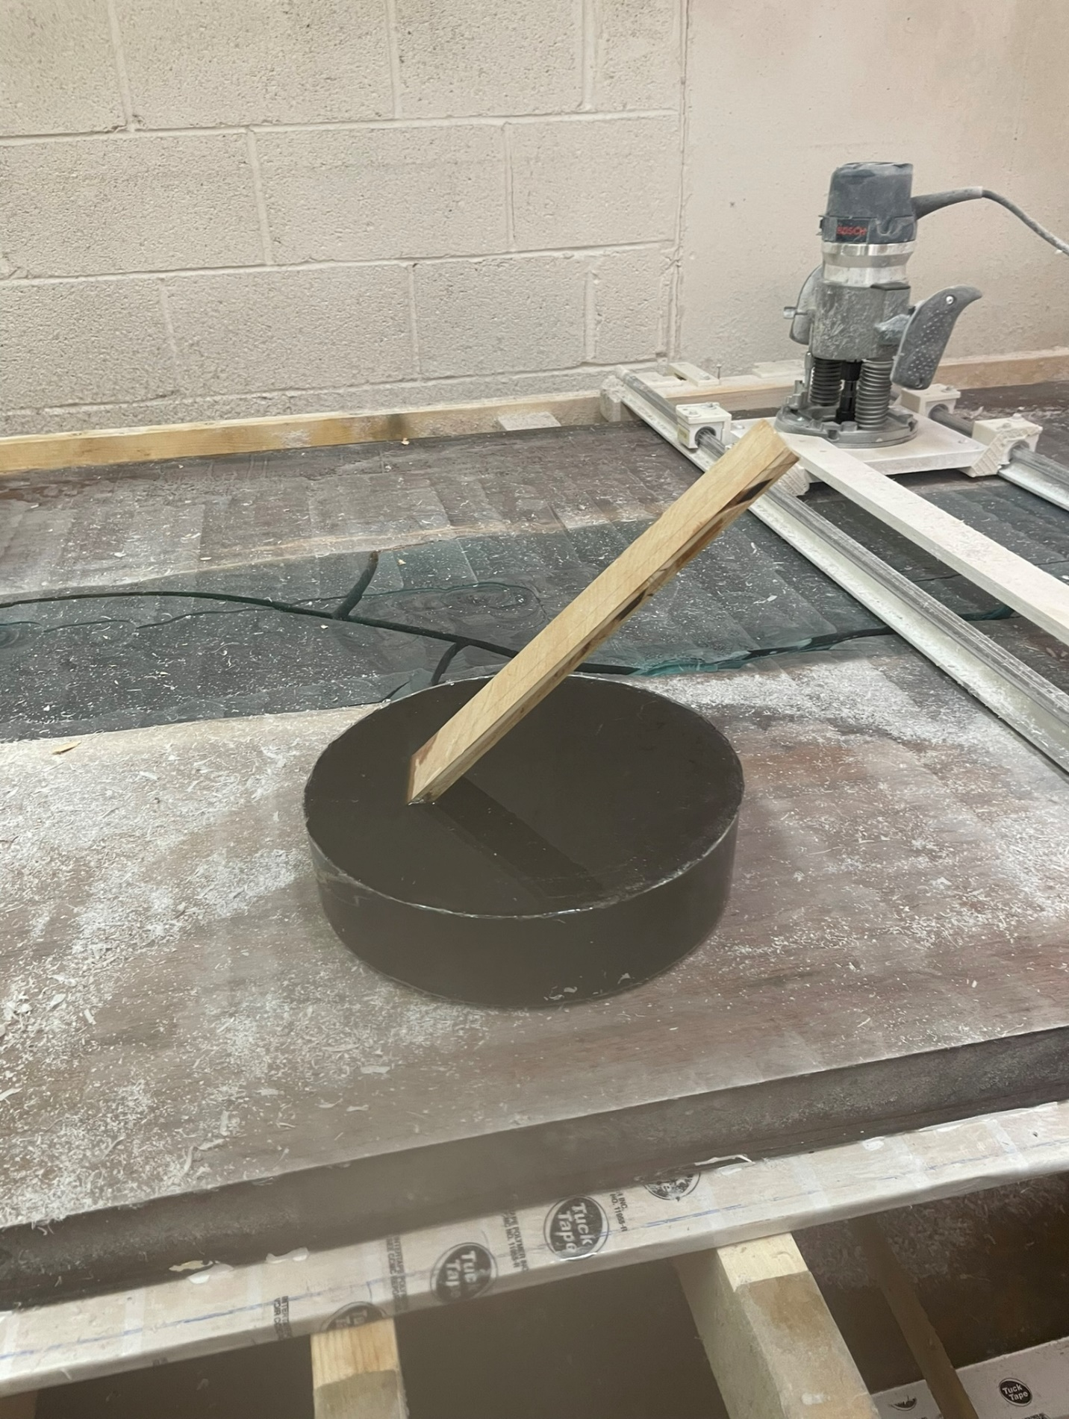

## Sealing

* If the Old Art Room has the AC running, a sealer coat takes 16 hours, otherwise 18-20 hours.
* Any cracks in wood can easily leave bubble trails. Fully seal before you pour either with epoxy or with Thick CA glue.
* I did walnut. Some sections, especially a ledge, took 6 coats to fully seal. After 2 coats, use a tabletop epoxy if you are on a timeline.
  + Sand with 180 between sealer coats
  + Sanded epoxy creates a white powder. If there is a bubble that is filled with epoxy powder, on the next sealer coat, dab at it with your brush to make it clear again. Alternatively, you can blow it out, vacuum it out, or use dental picks or screws. These bubbles tend to be big enough where the brush works just fine though.
* If you plan on sealing your workpiece propped above your form, and are not immediately going to drop the piece into the form (like if the workpiece might need more than one sealer coat)
  + Cover your form with a plastic drop cloth. Otherwise, drips will screw up your form and your form will have to be reprepped before the pour.
  + For the sealer coat, allow your workpiece to dry with the topside down (that is the last side to be fully submerged during the pour facing down). Otherwise, the sealer coat drip marks are more important to deal with, and that’s a waste of time. To elaborate, how they are drying here, if I didn’t sand the drip marks off, it would throw off the width of my table.

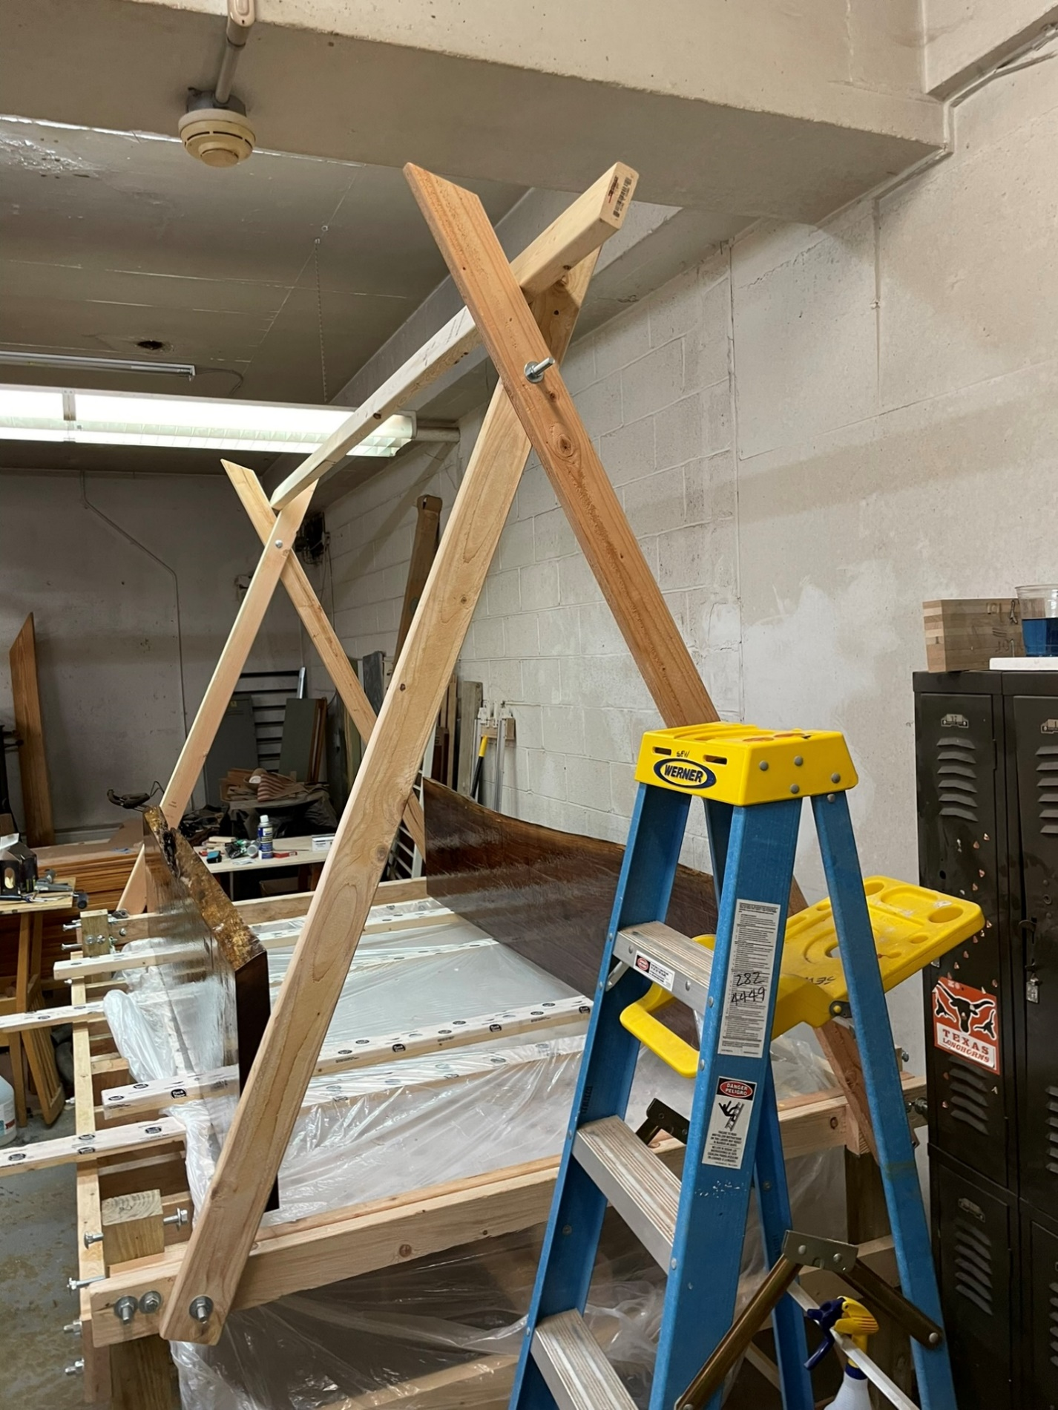

## Caulk

I used GE Window & Door Projects All Purpose Silicone, and it worked perfectly. Keep in mind that the seam will cause your slab not to seat perfectly on the edges. For my 4’ wide table, I lost 1/4” width.

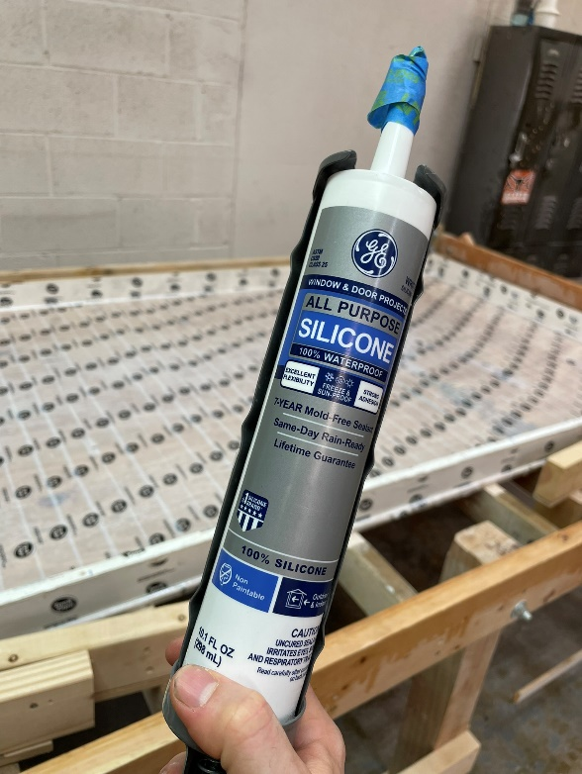

## Prepour

* Wipe down with isopropyl 91+. Safeway has cheap bottles, but the ones from harris teeter have the squirt top.
* Cool the room and use fans above and below the foundation to keep it cool.
  + I know without AC you can get away with ~2 gallons at 80 degrees in the Old Art Room.
  + For big pours (greater than 6 gallons), cool the epoxy (keep it in the old art room) for a few days prior to pour to keep it from overheating and cracking.
    - With AC on full blast and a few days to cool off, I did a 6 gallon pour successfully. You can probably get away with more, but I figured better safe than sorry.

## Pour

* If the Old Art Room has the AC running, 3-6 gallons takes ~39 hours to cure depending on humidity (for pours 0.25” to 1.25”).
* If you really are looking for a perfect pour, don’t. But you can try degassing the epoxy, and plan on possibly not using a fan above the pour. The fan may or may not have caused more bubbles in my last pour. It’s voodoo at this point for me.

## Between Coats for Multi-Pour

* I found that sanding to 180 grit is rough enough for epoxy to bond to itself and not leave residue. In fact, when my project failed, the two pour layers adhered well enough to one aonther that it actually broke the bottom layer that had already previously cured.
* If 2-part pour, and there are pits on the bottom layer from bubbles, watch out for sanding dust. If so, either clean out with vacuum/air, pick with dental pics, or force epoxy into it with a brush on next pour. I’d recommend pouring isopropyl on it to determine what needs to be addressed before doing the next pour
* If clear/translucent, make sure there are no fingerprints.
* Wipe with isopropyl 91+. Dries quicker than water.

## Fail

If the pour gets too hot, the epoxy will cure too fast and then crack. 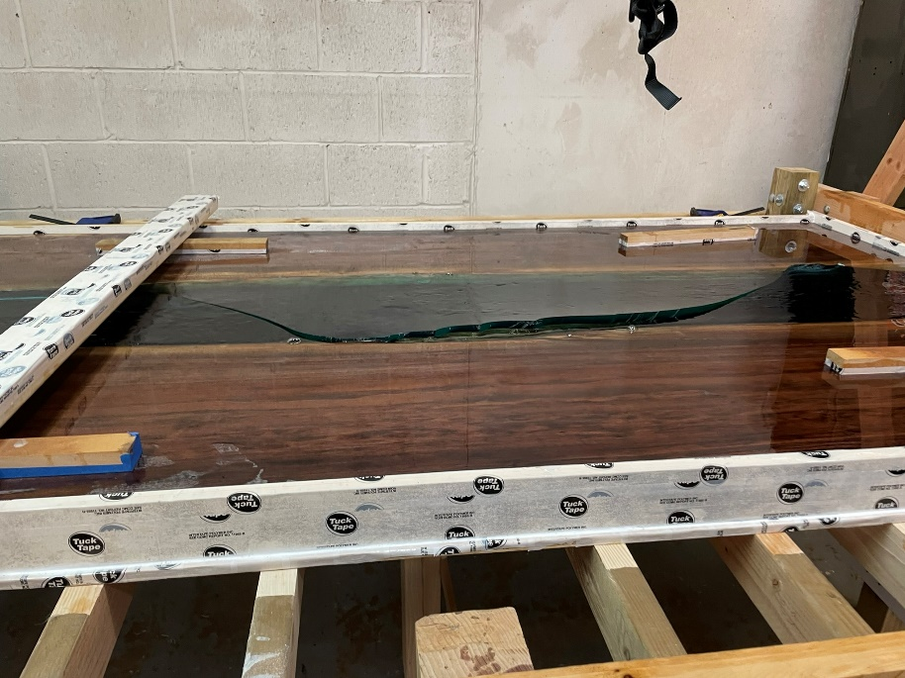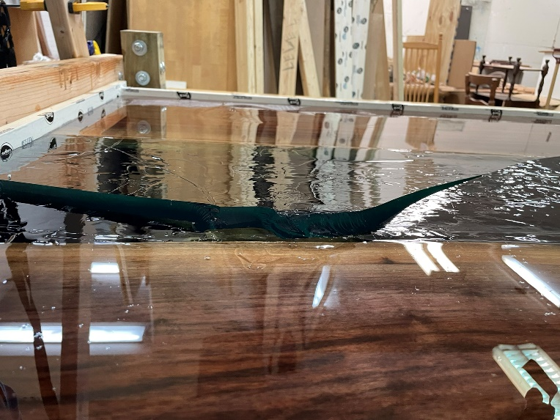

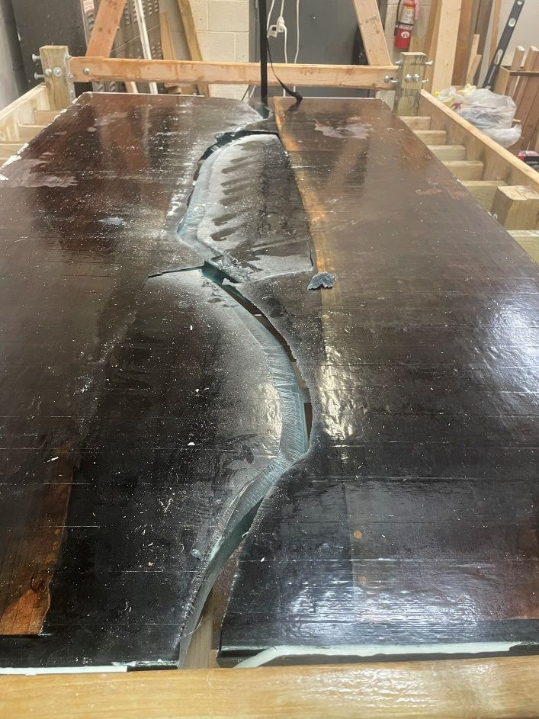

You can throw it away or spend $100 on a [4.5” angle grinder](https://www.harborfreight.com/power-tools/grinders/angle-grinders/7-amp-4-12-in-slide-switch-angle-grinder-64856.html) and accessories from Harbor Freight. It’s actually lots of fun. But super messy. Use a respirator and goggles. Swim goggles are great for this task.

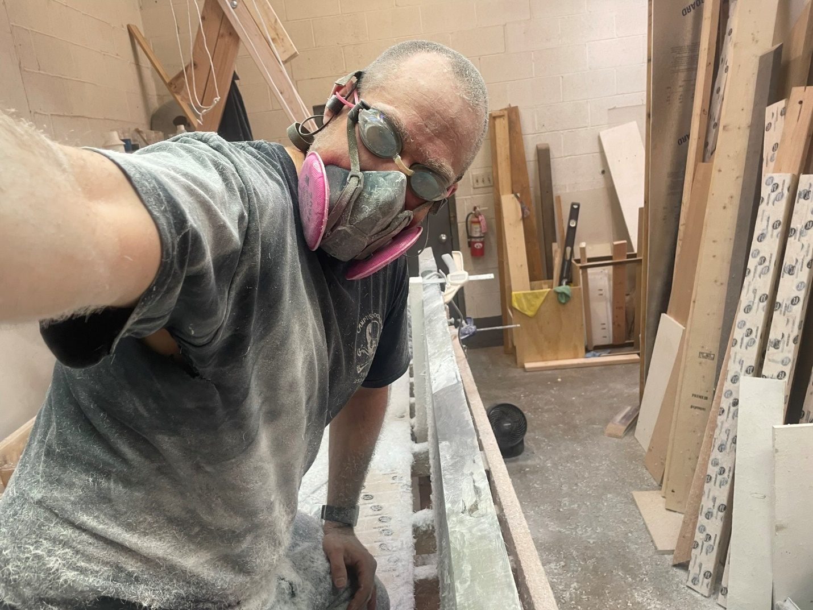

* To repair cracked epoxy: Circular saw > Jigsaw (optional) > Angle Grinder (AG) with Segmented Wheel > AG Steel Wood-Shaping Dish > AG 36 grit sanding disc > Sander.
* Accept the fact that you will reshape when you gouge the wood if dealing with intricate stuff.

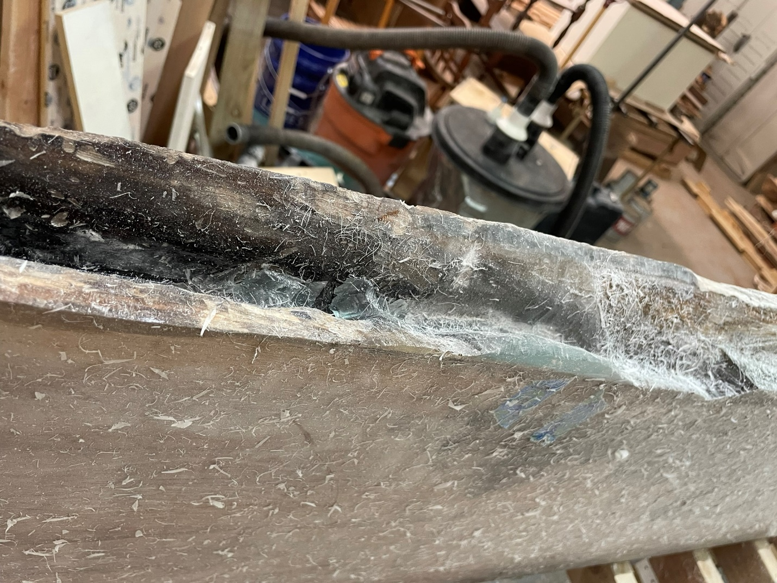

* For intricate stuff or weird shapes around the live edge, a Dremel with bur bits and then upcut or downcut bits work well.

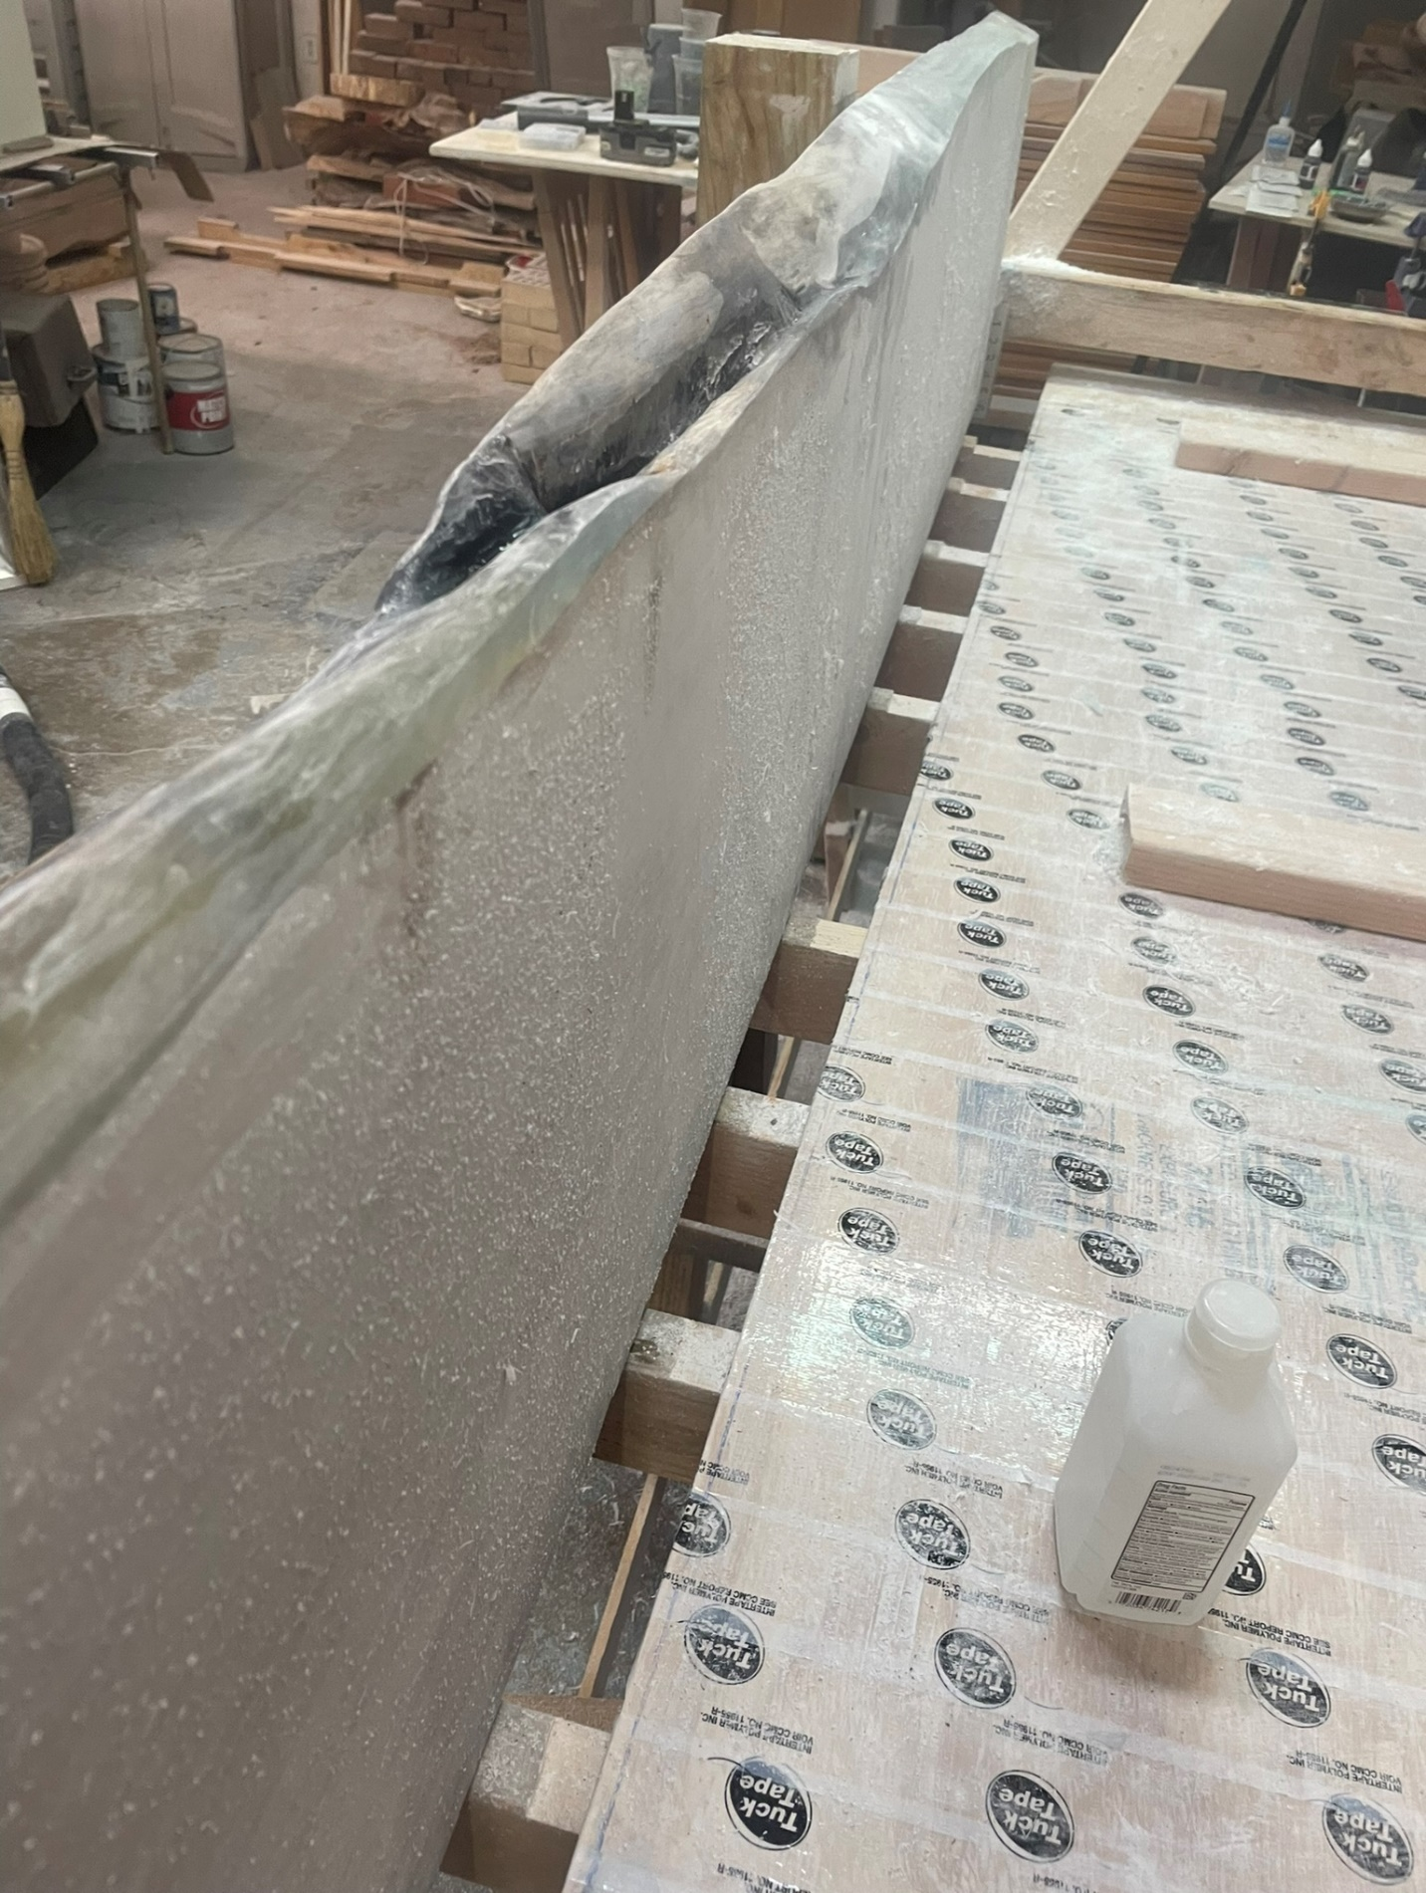

# Finishing

## Imperfection Repair

Use clear CA glue unless the hole is big enough to not drip black outside of it. Otherwise, it will bleed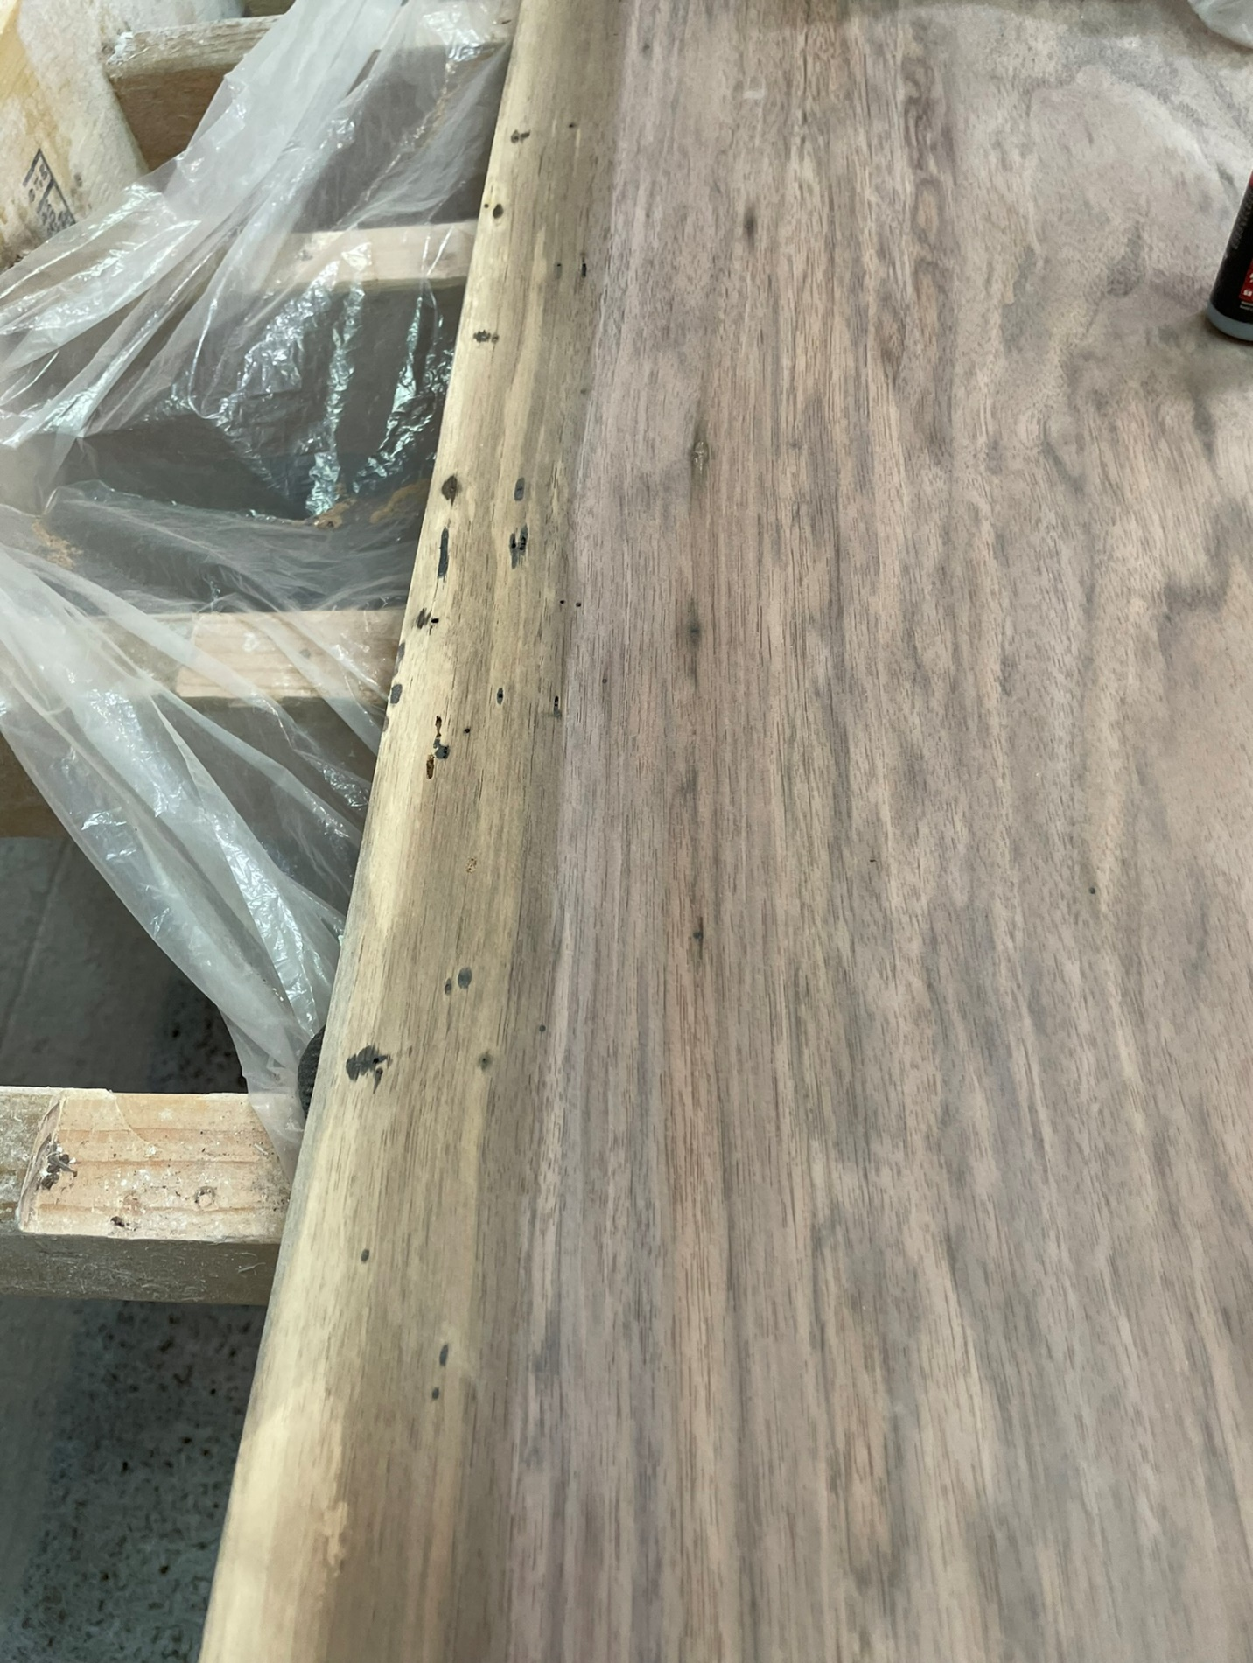.

Accelerator is good when the crack is big enough to need thick epoxy. Otherwise, the accelerator can cause the glue to turn white or can leave a gap below the top layer that you will struggle to fill as you progressively sand finer.

Here’s what the progression looks like: CA, sand 180, CA, sand 120, CA, sand 180, CA, sand 180, give up.

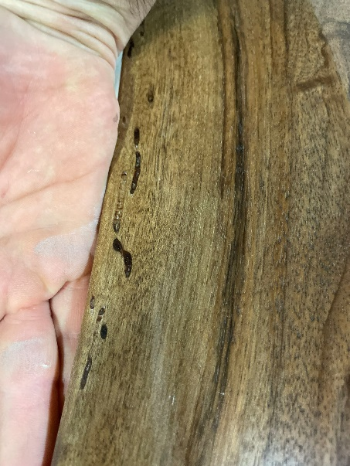

## Sander

A great sander will save you hours. I originally bought this [Bosch 5” Random Orbital Sander](https://www.homedepot.com/p/Bosch-2-5-Amp-5-in-Corded-Variable-Speed-Random-Orbital-Sander-Polisher-Kit-with-Carrying-Bag-ROS20VSC/203866770?source=shoppingads&locale=en-US) thinking it would be phenomenal. For big projects, or small epoxy projects, you will spend hours sanding. I only use this if I am going to polish something now.

By “great” sander, I mean one with a stroke length (also called Orbit Diameter) of at least 3mm; but 5mm is ideal. You also need active dust collection for your sandpaper to last.

I did my research and the only two quality brands on the market are Festool and Mirka. I didn’t like the paddle switch on the Mirka because I like to change my grip and was ultimately between the Festool RO150 (6” Rotex) and the Festool ETS EC 150/5. I went with the 150/5 because the I wanted a more ergonomic sander, thought the Rotex mode wasn’t something I would need too often, and ultimately didn’t want to spend any more. You also need [protection pads](https://www.rockler.com/festool-granat-net-protection-pad-for-sanders-2-pack) (non-cushioned interface pads), Interface pads (buy the thin one that’s a 2 pack), and the two separate dustright connectors for a shopvac while you are there: Dust Right Click-Connect FlexiPort (I don’t know which size) & [Adapter](https://www.rockler.com/flexiport-click-connect-adapter-for-shop-vacuum-hoses).

To see how much a good sander makes a difference, refer to:

Sanding

I use 3M Cubitron (80, 120, and 180 grit) sandpaper. On wood, it lasts way longer than any other sandpaper, so ultimately it is cheaper. Check TayTools, Amazon, and Rockler for sales. Woodcraft doesn’t carry it. Use a non-cushioned interface pad (like I recommended above) when using this sandpaper. Cheaper to replace these than the sander baseplate.

If you get swirl marks (pig tails), your sandpaper is clogged. Replace it with the same grit and sand until the swirl is gone. You cannot sand past the swirls with a finer grit.

Spray wood with water between grits (water pop) and allow a little time to dry. It will raise the grain and give you better results.

# Appendix

## Useful calculations

[FGCI Deep Pour 2-4” Epoxy](https://www.superepoxysystems.com/product/liquid-glass-deep-pour-epoxy/?attribute_kit-size=3+Gallon+Kit&gad_source=1) uncured weight: 9 lbs/gallon.

Calculator

* [FGCI](https://www.google.com/url?sa=t&source=web&rct=j&opi=89978449&url=https://www.bestbartopepoxy.com/pages/epoxy-calculator&ved=2ahUKEwiriJ6D_rqIAxXGKFkFHalPKDQQFnoECA8QAQ&usg=AOvVaw1_ufttAt1gyGt3QI9MN1Hf)
* [Blacktail](https://www.blacktailstudio.com/epoxycalculator)

## Useful knots

[Retraced Figure 8](https://www.alpinesavvy.com/blog/how-to-tie-the-perfect-retraced-figure-8)

Figure 8

Constrictor knot – Cannot be untied!

Alpine Butterfly

Bowline

## Common Lumber Weight and Hardness

[Common Wood Species Guide](https://www.wood-database.com/)

|  |  |  |
| --- | --- | --- |
| Species | Average Dried Weight (lbs/ft3) | Janka Hardness (Newtons) |
| Black Walnut | 38 | 4490 |
| Hard Maple | 44 | 6450 |
| Silver Maple | 33 | 3110 |
| Soft Maple |  |  |
| White Oak |  |  |
| Red Oak | 44 | 5430 |
| Honey Mesquite | 51 | 10410 |
| Eastern Aromatic (Red) Cedar |  | 4000 |
| Pine  (from HD/Lowes) | 28-34 | 2050-2250 |
| Poplar |  | 2400 |
| English Walnut |  |  |
| Rubberwood |  |  |
| Cherry |  |  |